User Experience Design Project Report

**On**

Online Crime Reporting System

**Developed By: -**

Yuvraj Jadav (20162171008) Jay Kumar Sapra (20162171009) Kushlendra Singh (20162171010)

**Guided By: -**

Prof. Bhavesh Jain (Internal)

**Submitted to**

**Department of Computer Science & Engineering Institute of Computer Technology**



**Year: 2022**



# CERTIFICATE

This is to certify that the **User Experience Design** Project work entitled **“Online Crime Reporting System”** by Yuvraj Jadav (Enrolment No. 20162171008), Jay Kumar Sapra (Enrolment No. 20162171009) and Kushlendra Singh (Enrolment No. 20162171010) of Ganpat University, towards the partial fulfillment of requirements of the degree of Bachelor of Technology – Computer Science and Engineering, carried out by them in the CSE(CBA/BDA/CS). The results/findings contained in this Project have not been submitted in part or full to any other University / Institute for award of any other Degree/Diploma.

Name & Signature of Internal Guide

Name & Signature of Head

**Place: ICT - GUNI**

**Date:**

# ACKNOWLEDGEMENT

User Experience Design project is a golden opportunity for learning and self -development. We consider ourself very lucky and honored to have so many wonderful people lead me through in completion of this project. First and foremost, We would like to thank **Dr. Hemal Shah, Principal, ICT**, and **Prof. Dharmesh Darji**, Head, ICT who gave us an opportunity to undertake this project. Our grateful thanks to **Prof. Bhavesh Jai** for their guidance in project work Predicting Application Rating of Google Play Store, who despite being extraordinarily busy with academics, took time out to hear, guide and keep us on the correct path. We do not know where would have been without his/her help. CSE department monitored our progress and arranged all facilities to make life easier. We choose this moment to acknowledge their contribution gratefully.

**Yuvraj Jadav (Enrolment No. 20162171008)) Jay Kumar Sapra (Enrolment No. 20162171009) Kushlendra Singh (Enrolment No. 20162171010)**

# ABSTRACT

Nowadays, much of the crimes committed were unreported to the authorities. Given this fact, the study presents the development of a Crime Management and Reporting System through online and even offline and at the same time is the active participation of the citizens. The idea draws its motivation from the inconvenience of going to the police station and personal belief of the weak investigative capabilities of the authorities to resolve petty crimes and limited spreading of crime information to the community. The project specifically looks into the crime detection and prevention. This study aims to provide an overview of the investigative process and, in doing so, identify effective and efficient approaches to the investigation and detection of the volume of crimes. The review is particularly aimed to highlight the research evidence those investigative practices and actions that are likely to lead to a positive outcome. The development of software includes the process of brainstorming and planning, requirements analysis, system analysis and designs, implementation and testing, deployment, and maintenance. The criteria of evaluation of software quality were adapted in ISO/IEC 25010:20011. This also shows that distance is also a fac tor that influences greatly how crimes are being handled with many crimes going unreported as a result. Crime Management and Reporting System would really help the complainant and the authority to communicate privately and easily with regards to the reported issue. In addition, it would be easier for the complainant to report a witnessed crime without the fear of getting involved in the problems because of the security that the only authorized user can see the report. Verification using Biometric is highly recommended to enhance the security of data stored in the system. This increases the restriction on access to the system, thus unauthorized users have no access to the system.

Keywords: Biometric, crime management, online, reporting system, software quality

IV

# TABLE OF CONTENT

|  |  |  |  |
| --- | --- | --- | --- |
| **Title** | | | **Page No.** |
|  | **Title Page** | | I |
|  | **Acknowledgment** | | III |
|  | **Table of Content** | | V |
| **1.** | **Introduction** | | 1 |
|  | 1.1 | Project Summary | 1 |
|  | 1.2 | Project Scope | 1 |
|  | 1.3 | Objective | 1 |
|  | 1.4 | Literature Review/Background Study | 1 |
|  |  | |  |
| **2.** | **System Requirement Study** | | 2 |
|  | 2.1 | Hardware and Software Characteristics | 2 |
|  |  | |  |
| **3.** | **System Analysis** | | 3 |
|  | 3.1 | Study of Current System and Requirement of this System | 3 |
|  | 3.2 | Data Dictionary | 5 |
|  | 3.3 | Modules and Their Description of System | 6 |
|  |  |  |  |
| **4.** | **System Design** | | 8 |
|  | 4.1 | Design Pseudocode or Algorithm for Method or Operation | 8 |
|  | 4.2 | Flow Chart Diagram | 8 |
|  |  | |  |
| **5.** | **Screenshots** | | 12 |
|  | 5.1 | Frontend/Client/End User Side Screenshots | 12 |
|  | 5.2 | Backend/Admin Side Screenshots | 26 |
|  | 5.3 | Other Screenshots | 26 |
|  |  | |  |
| **6.** | **Conclusion And Future Work** | | 27 |
|  |  | |  |
|  | **REFERENCES** | | 27 |

**Chapter 1**

**Introduction**

* 1. **Project Summary**

In the modern world, the use of computers and Mobile phones are becoming rampant. More so, recent developments in ICT Industries have revolutionized and consequently brought about a paradigm shift in the way activities are accomplished. As a result of the crime reporting system needs to embrace these new technologies. This report has presented a simple, convenient, cost-effective, but efficient online crime reporting system with a user-friendly, sensitive and intelligible web interface. Whereby it can be accessed at any time provided there is an internet connection.

* 1. **Project Scope**

This website provides an architectural overview of crime management. This web site is generic. A web-based tool that enables the user to manage the crime on tasks completed as part of a project with tasks and sub-tasks. The tool includes interactivity, Functionality, Information will be stored into a database. Administrative and managerial functions will be provided including configuration projects/tasks/subtasks.

* 1. **Objective**

The main objective of the Online Crime Reporting System is to manage the details of Crime, Criminal, Public, Solutions, Department. It manages all the in-formation about Crime, Complaint, Department, Crime. The project is totally built at administrative end and thus only the administrator is guaranteed the access. The purpose of the project is to build an application program to reduce the manual work for managing the Crime, Criminal, Complaint, Public. It tracks all the details about the Public, Solutions, Department.

* 1. **Literature Review/Background Study**

**Chapter 2**

**System Requirement Study**

* 1. **Hardware and Software Characteristics**
     1. **Hardware**

|  |  |  |
| --- | --- | --- |
| **Sr. no.** | **Hardware** | **Specifications** |
| 1 | Processor | AMD RYZEN 5 |
| 2 | RAM | 8 Gb |
| 3 | HDD | 1 TB HDD/SSD |

* + 1. **Software**

|  |  |  |
| --- | --- | --- |
| **Sr. no.** | **Software** | **Specification** |
| **1** | Operating System | Window 10 |
| **2** | Software | * Eclipse Ide * MySQL Workbench * Adobe Dreamweaver * Visual Studio Code Postman |
| **3** | Programming Language | * Html/CSS/JavaScript * Bootstrap 5 * Java Basics * Jdbc * Servlet * Jsp * Theamleaf * Spring Boot * Spring Security * Spring MVC * Hibernate * Struts * Javax |
| **4** | Other Tools &tech | * Google * Nicepage |

# Chapter 3

**System Analysis**

* 1. **Study of Current System and Requirement of this System**
     1. **Study of Current System**
* This application does not allow users to recover their passwords.
* It is not going to allow users to ignore or remove their crime reports.
* It would also not allow changing in their profile.
* It is not fully secured as anyone can visit anyone’s profile.

**3.1.1 Study of Current System Screenshots**

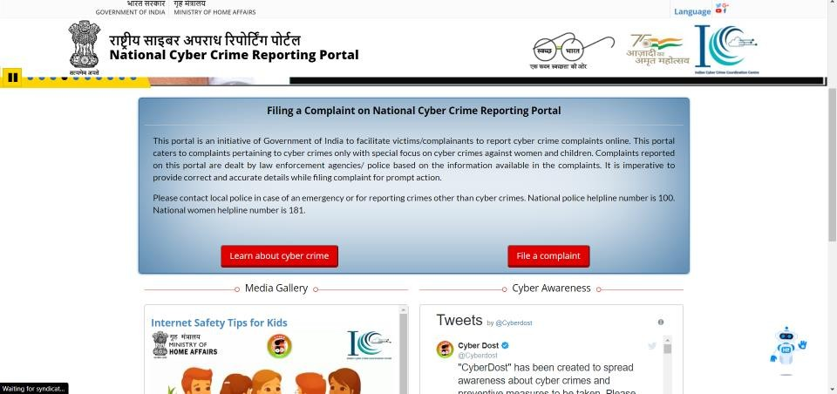

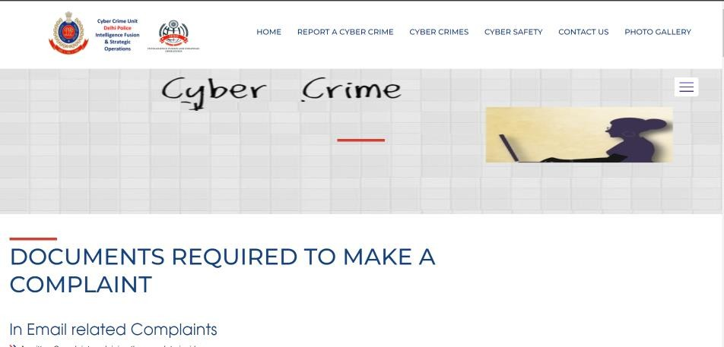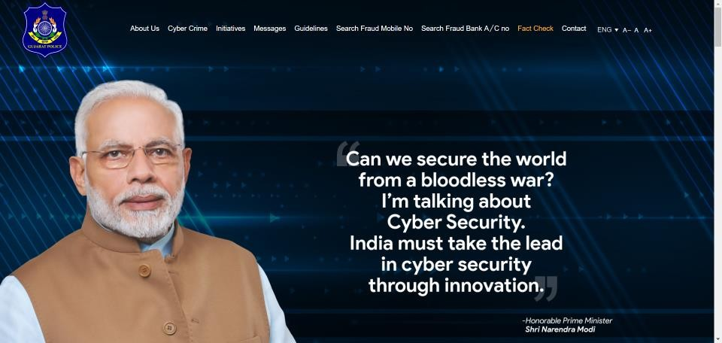

* 1. **Data Dictionary**
     1. **Casefile Data Table**

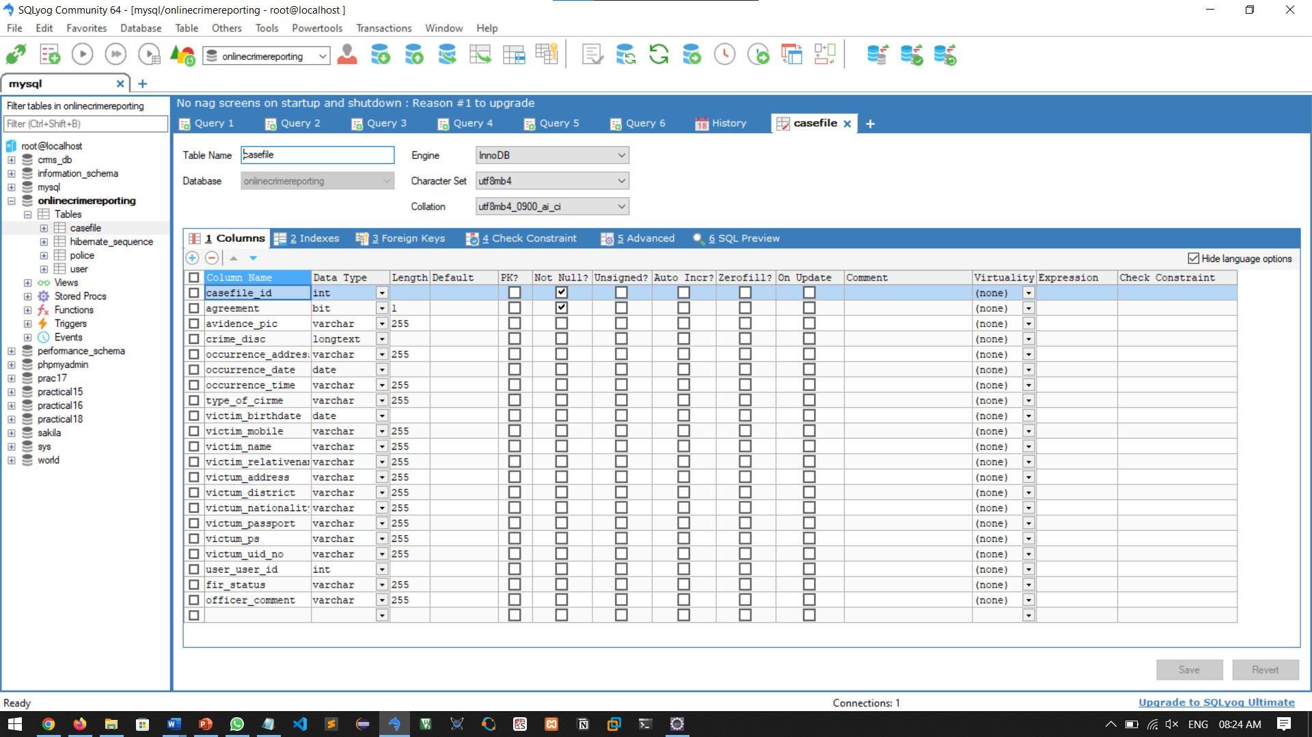

* + 1. **User Data Table**

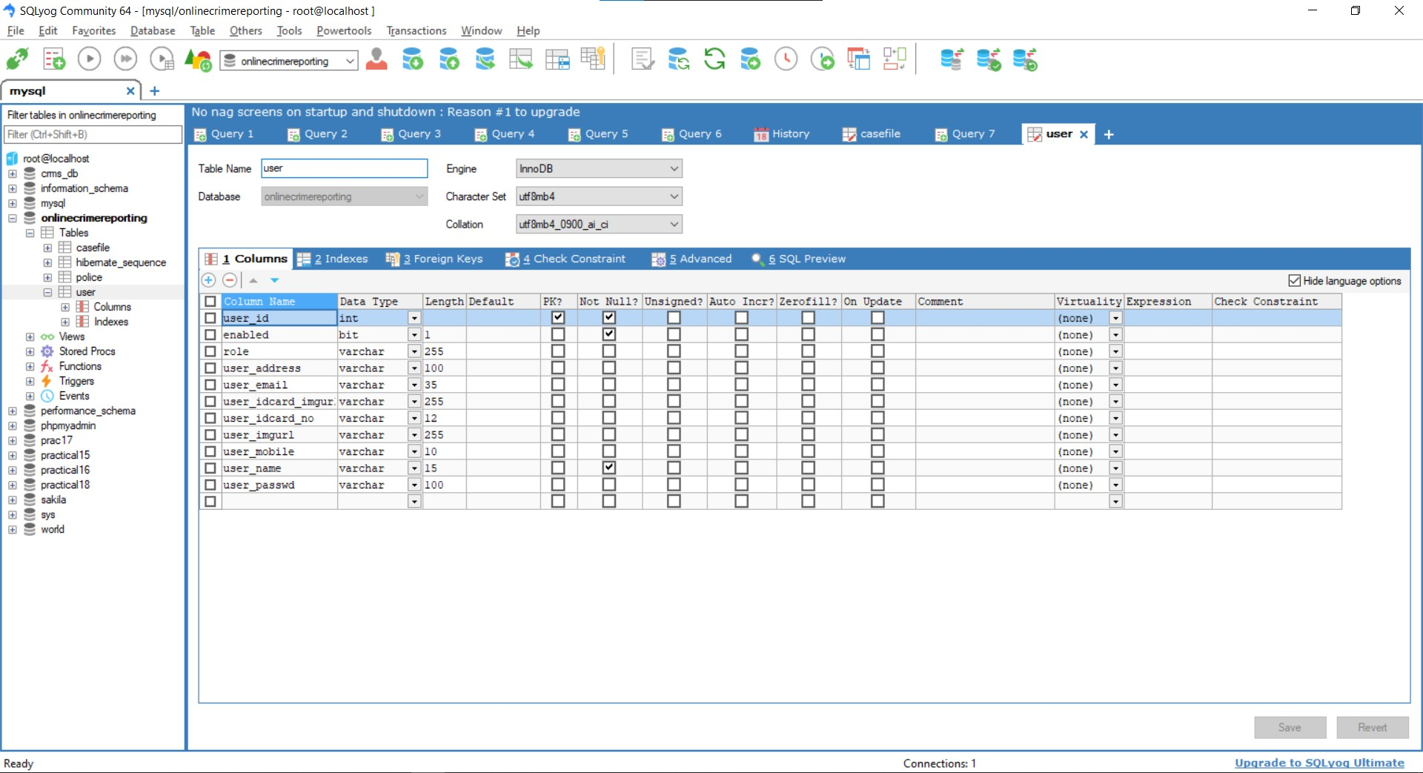

* + 1. **Police Data Table**

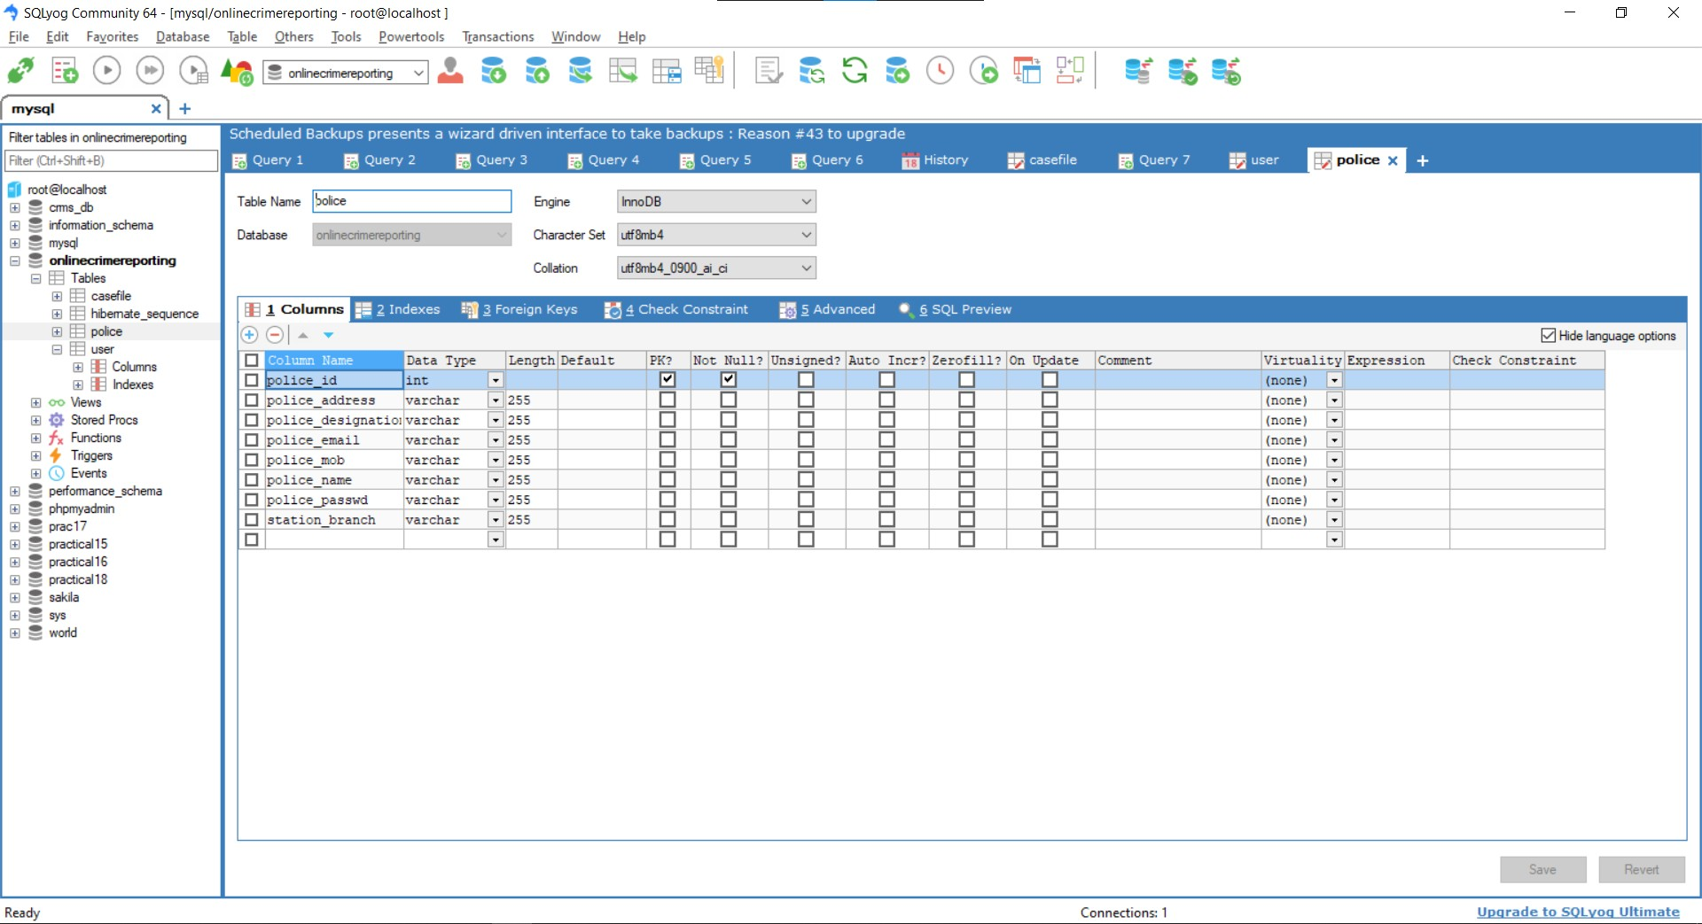

* 1. **Modules and Their Description of System**

TOTAL MODULE

LOGINPAGE 1

MAIN PAGE 2

ADMIN PAGE 3

USER PAGE 4

OFFICER PAGE 5

1. Login Page
   * It is a basic login page where the user is allowed to access the webpage only if it's valid.
   * And also, we are filtering the admin and local user for more features availability (Admin Part)
2. Main Page
   * The main page is divided into 3 main parts.
3. Login User Details
4. Question Writing Area/Text area
5. Previous Question List
6. Admin Page
   * All control of the webpage is available here from answering the question blocking user. And selecting teachers for each subject and semester.
7. Add/Update/Display/Delete Police Officer (Police Station)
8. Add/Update/Display/Delete Citizen (User)
9. Update/Display/Delete Complaint
10. View/Delete Complaints Status
11. View/Delete Emergency Complaint
12. View Query
13. View Feedback

|  |  |  |
| --- | --- | --- |
| IV. |  | User Page |
|  | • | The user can register himself and register fir and can update his profile and can track |
|  | 1. | his fir status.  Registration and login page |
|  | 2. | Notify to your near police station |
|  | 3. | Awareness about cyber hygiene |
|  | 4. | Complain anonymously |
|  | 5. | Add/update/delate complains |
|  | 6. | Uploading system for files like photos, pdf, etc. |
|  | 7. | Proper guidance to problem solutions |
|  | 8. | Tracking to your complain |

# Chapter 4

**System Analysis**

* 1. **Design Pseudocode or Algorithm for Method or Operation**

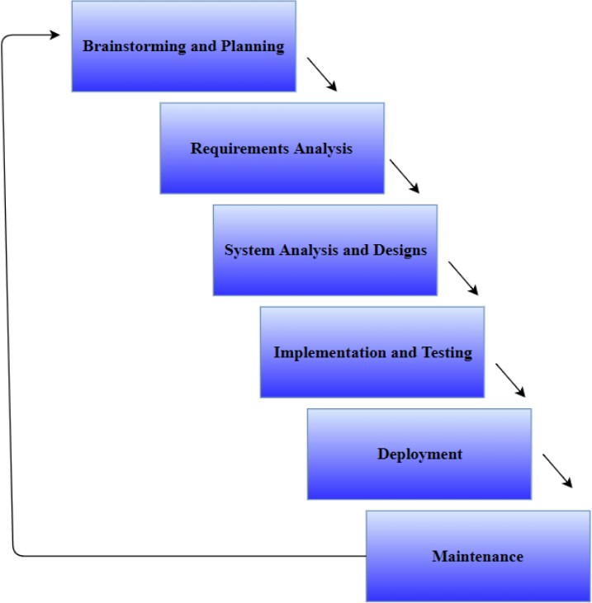

* 1. **Flow Chart Diagram**

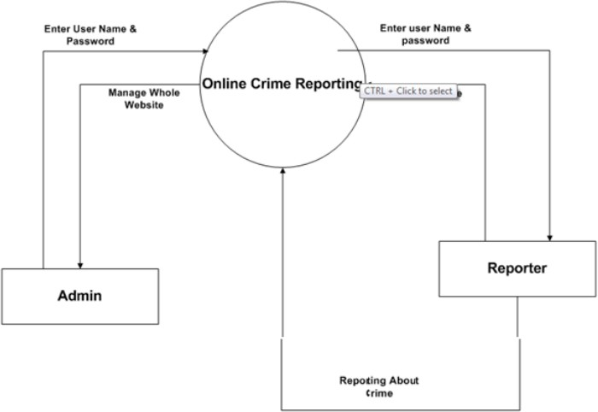

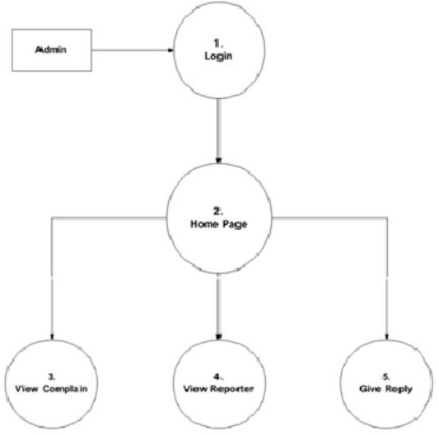

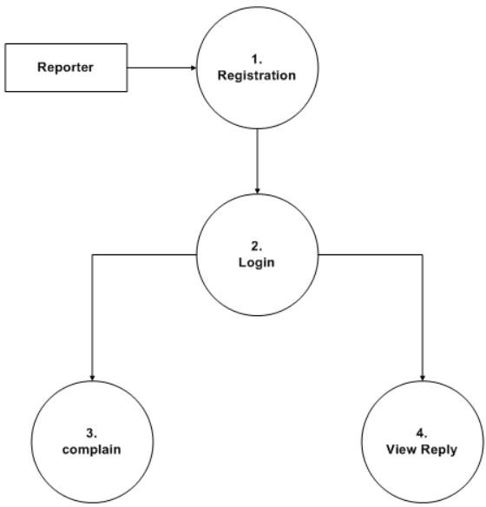

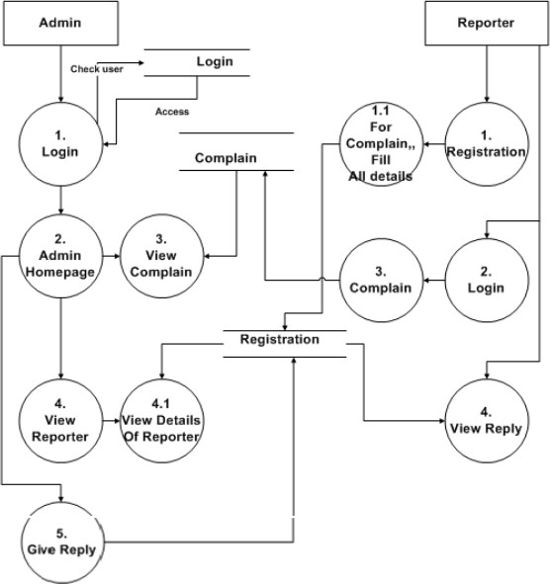

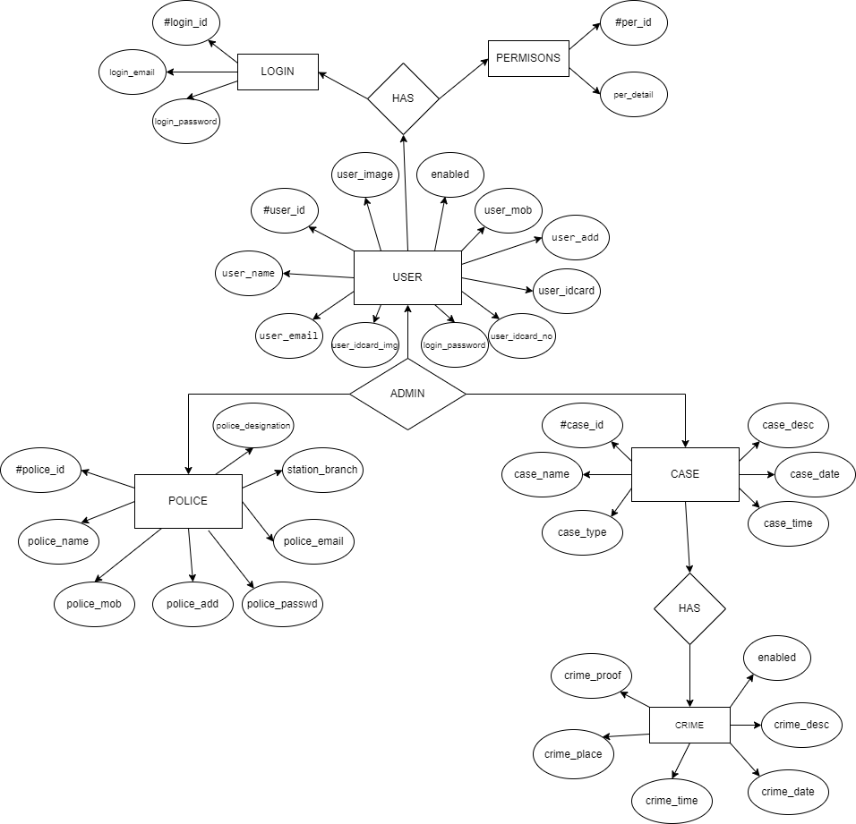

# Chapter 5

**Screenshots**

* 1. **Frontend/Client/End User Side Screenshots**
     1. **Home page**

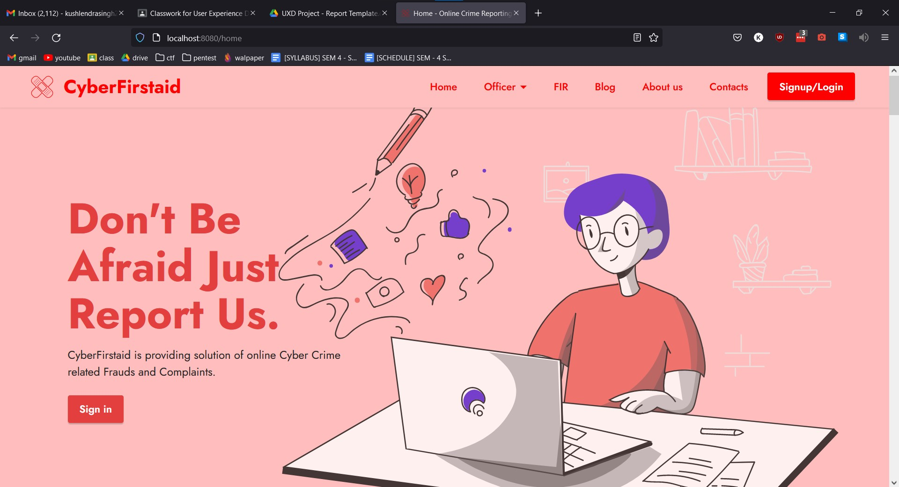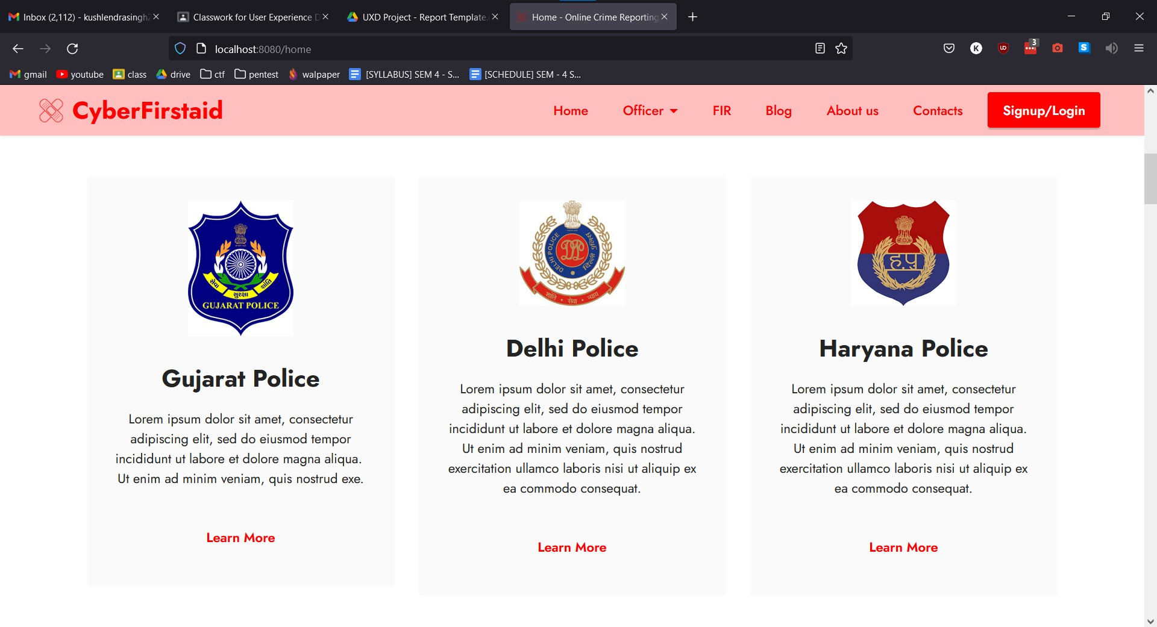

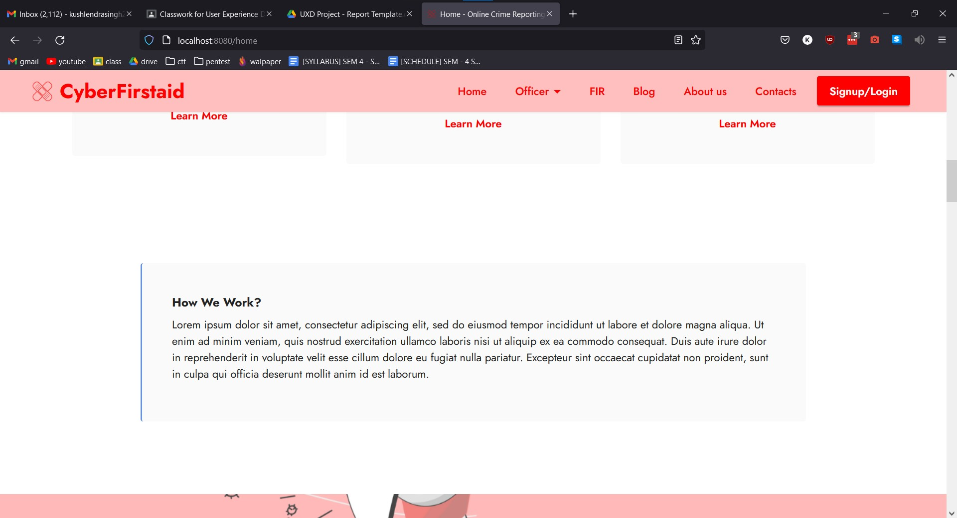

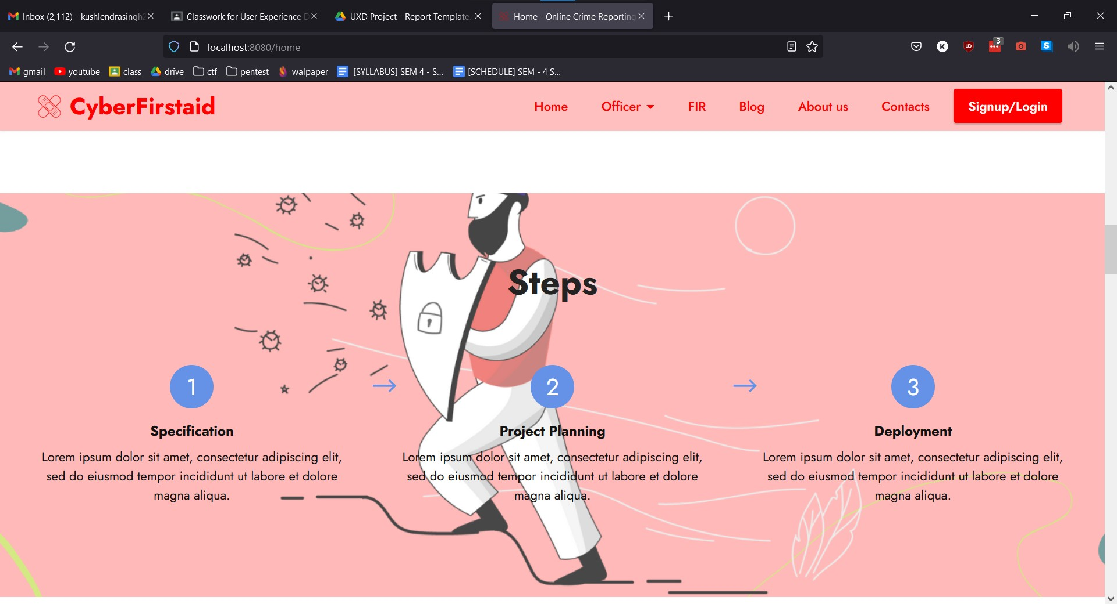

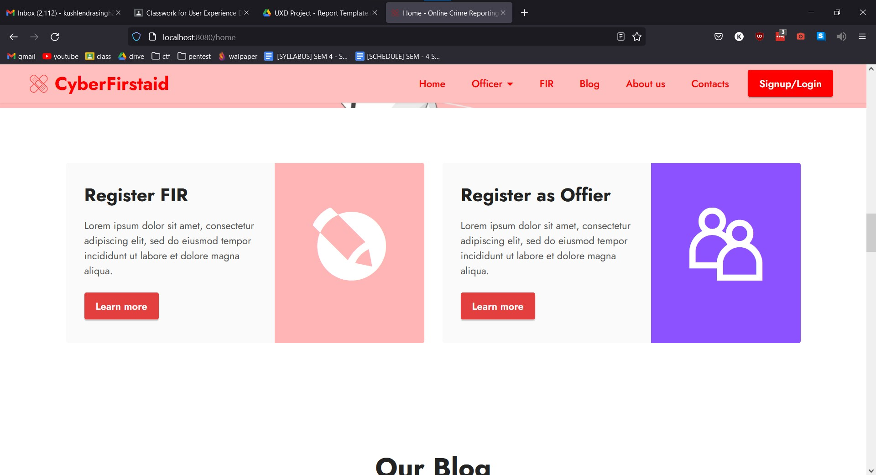

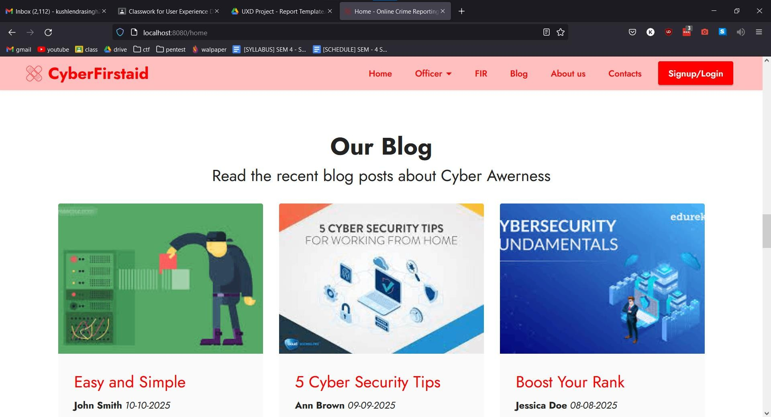

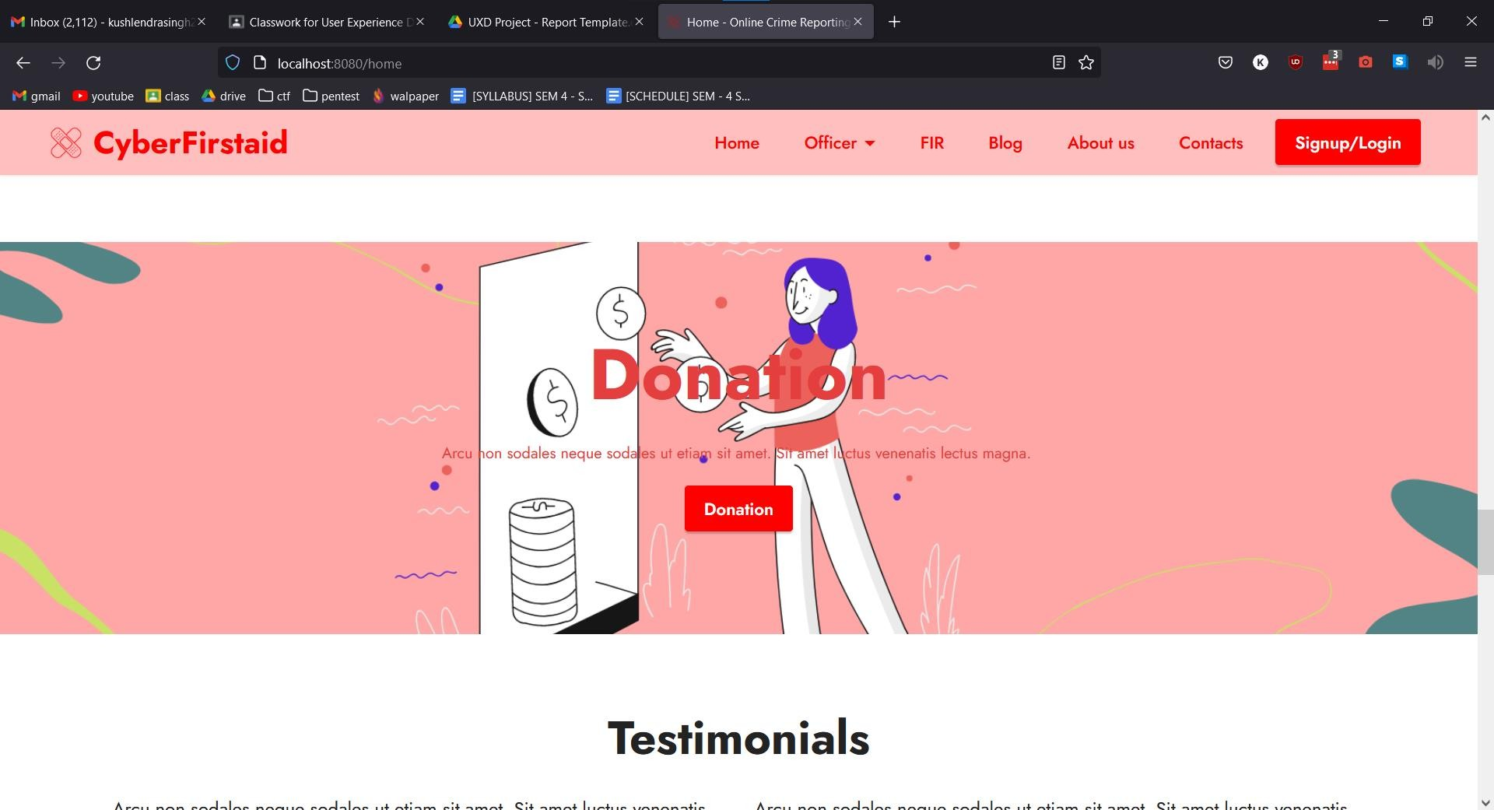

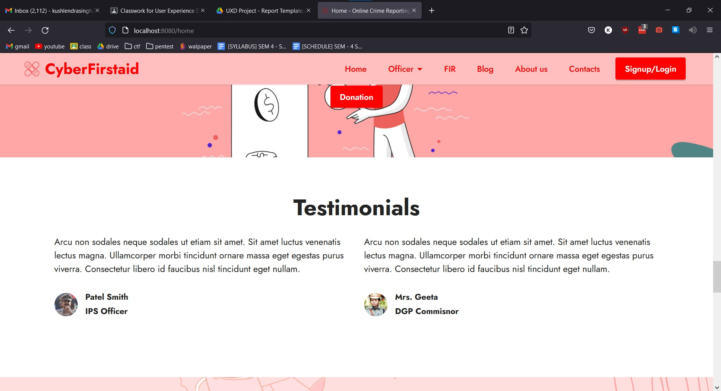

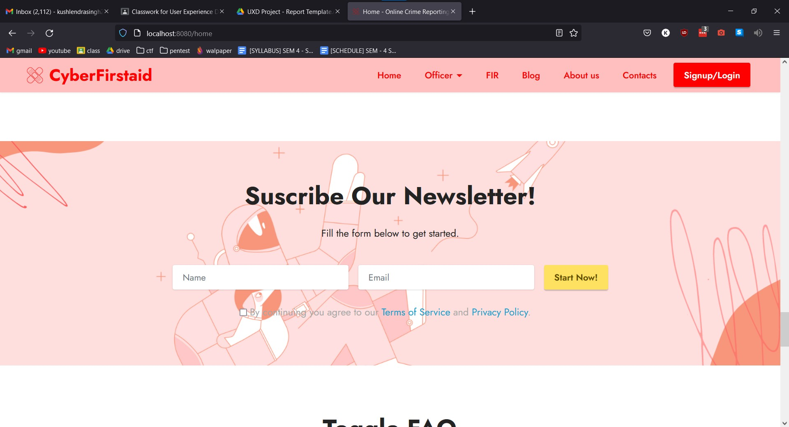

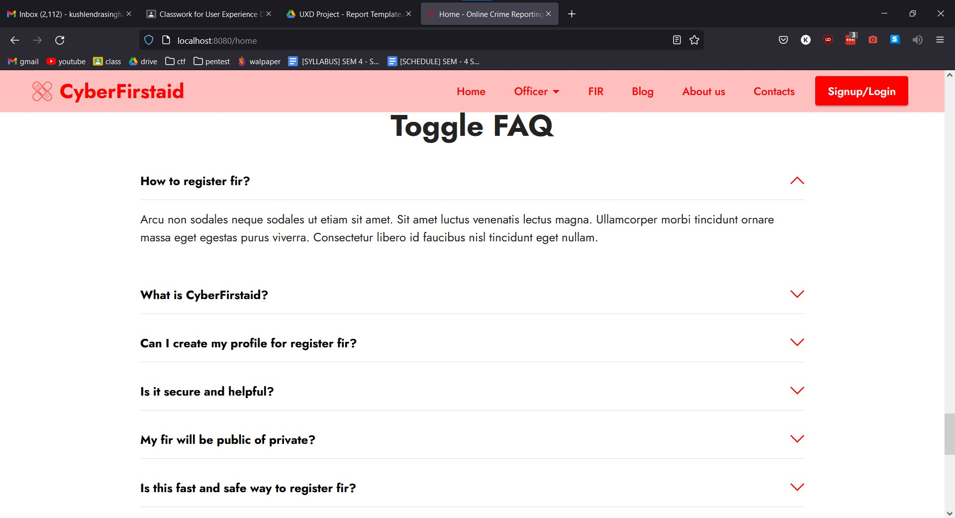

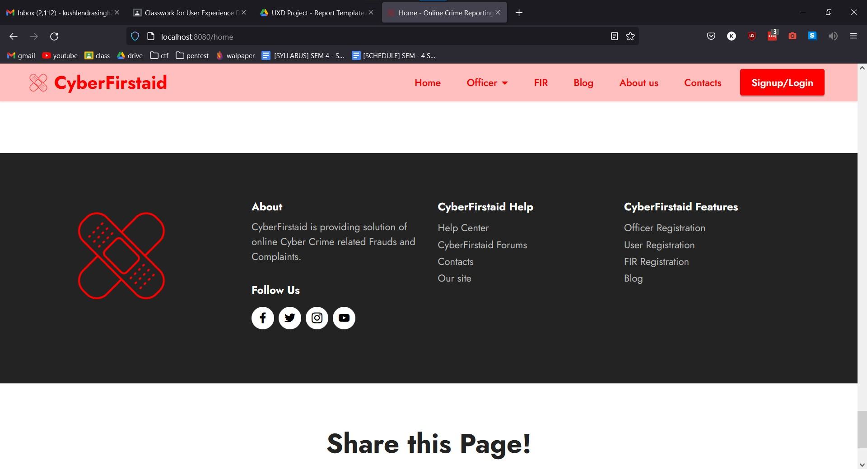

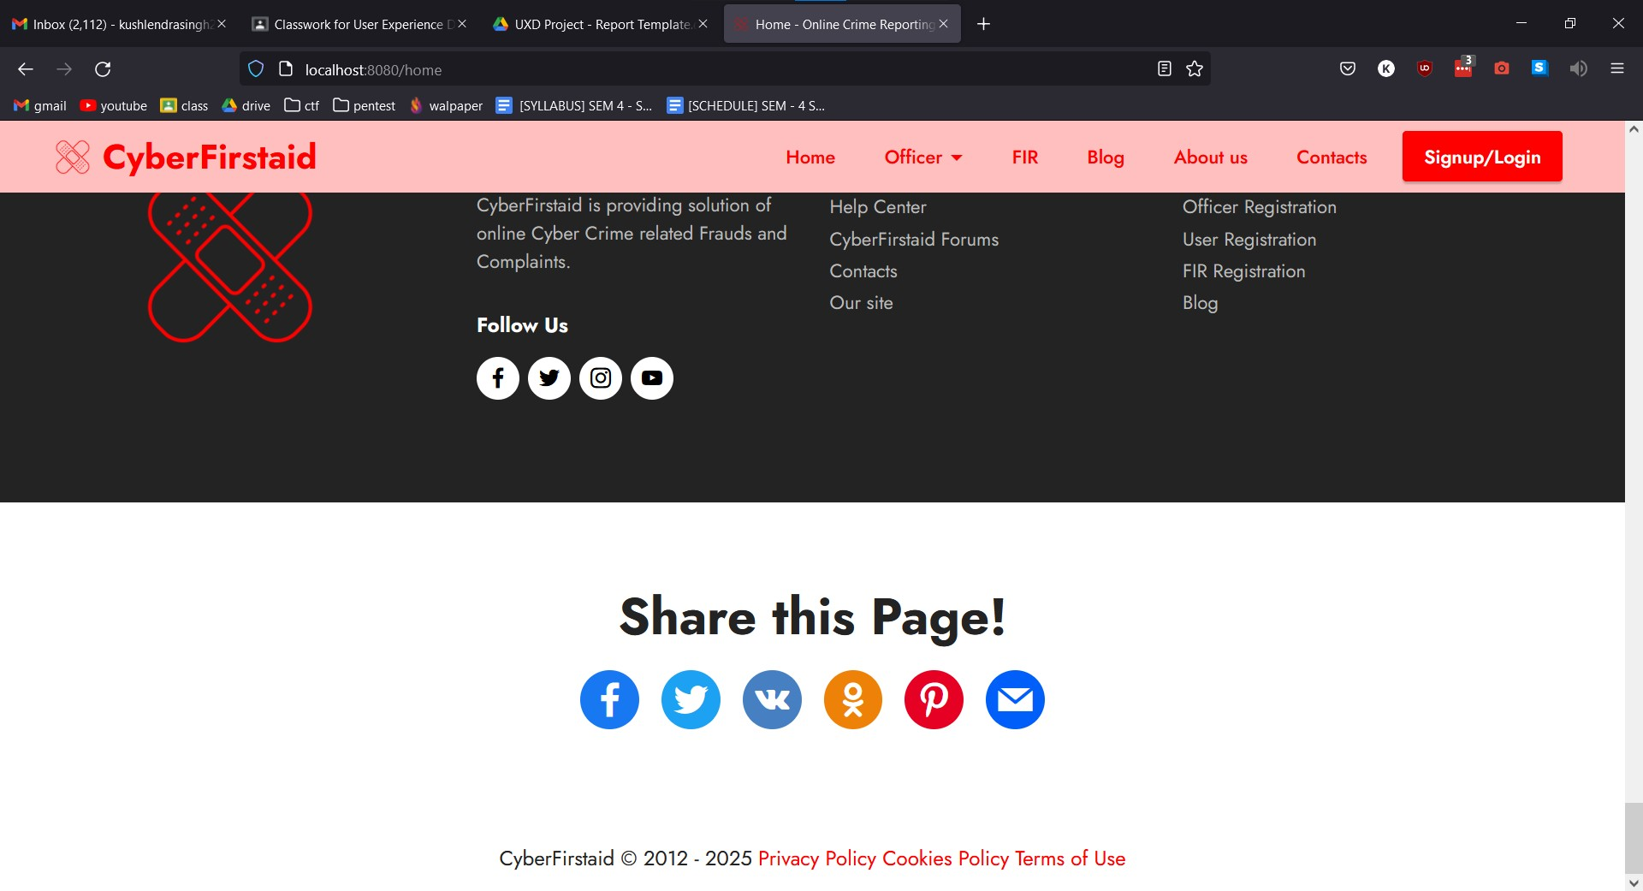

* + 1. **Login page**

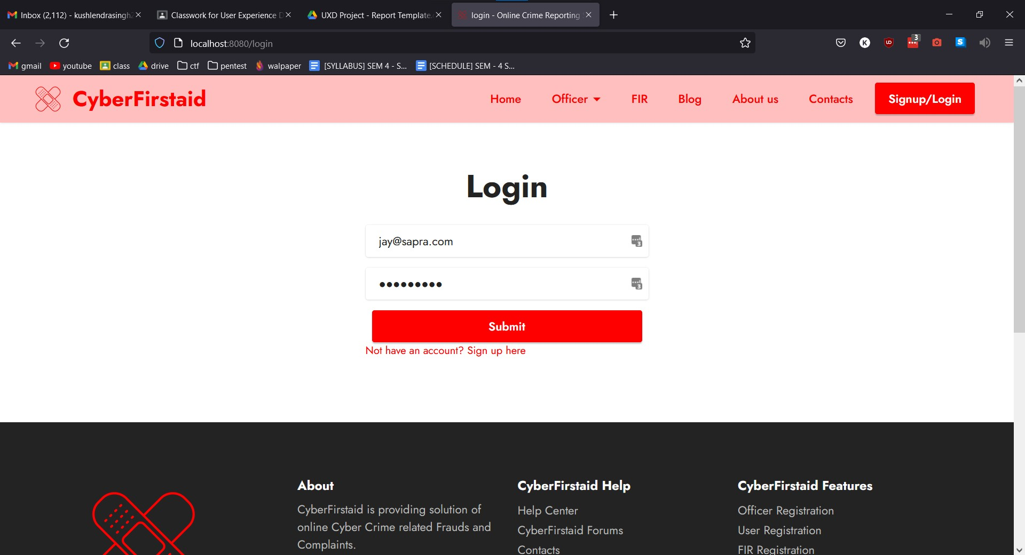

* + 1. **Signup page**

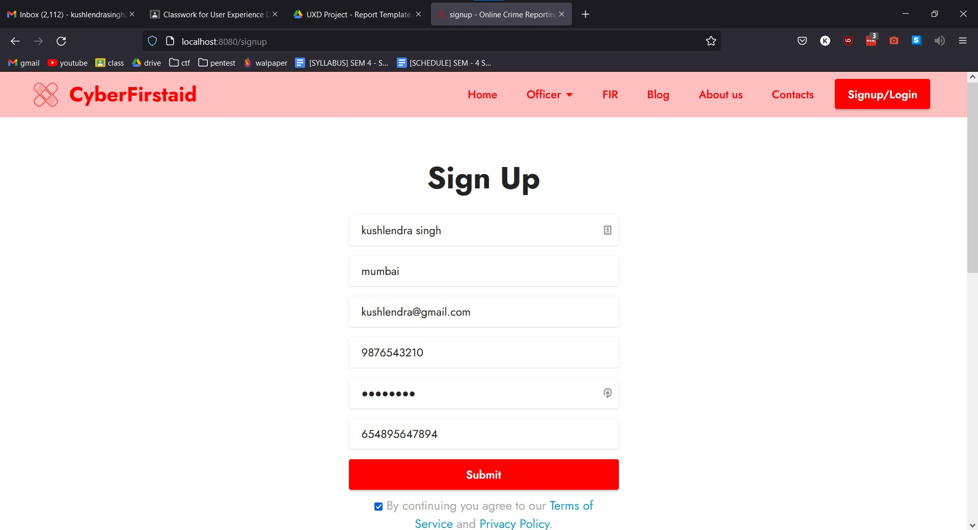

* + 1. **User Dashboard page**

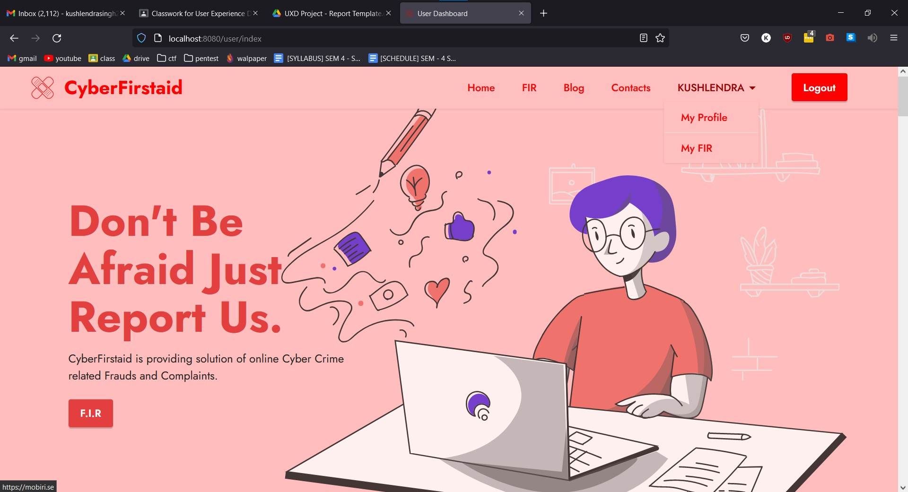

* + 1. **FIR Register page**

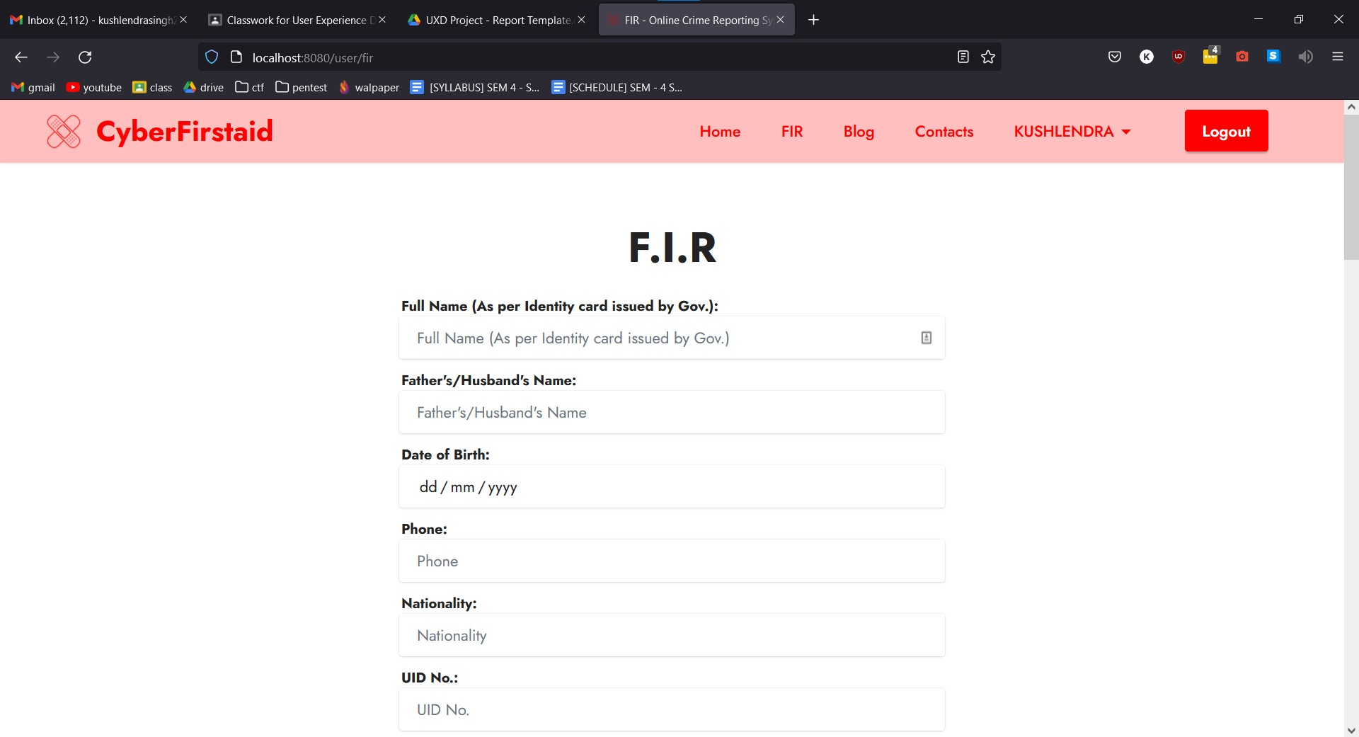

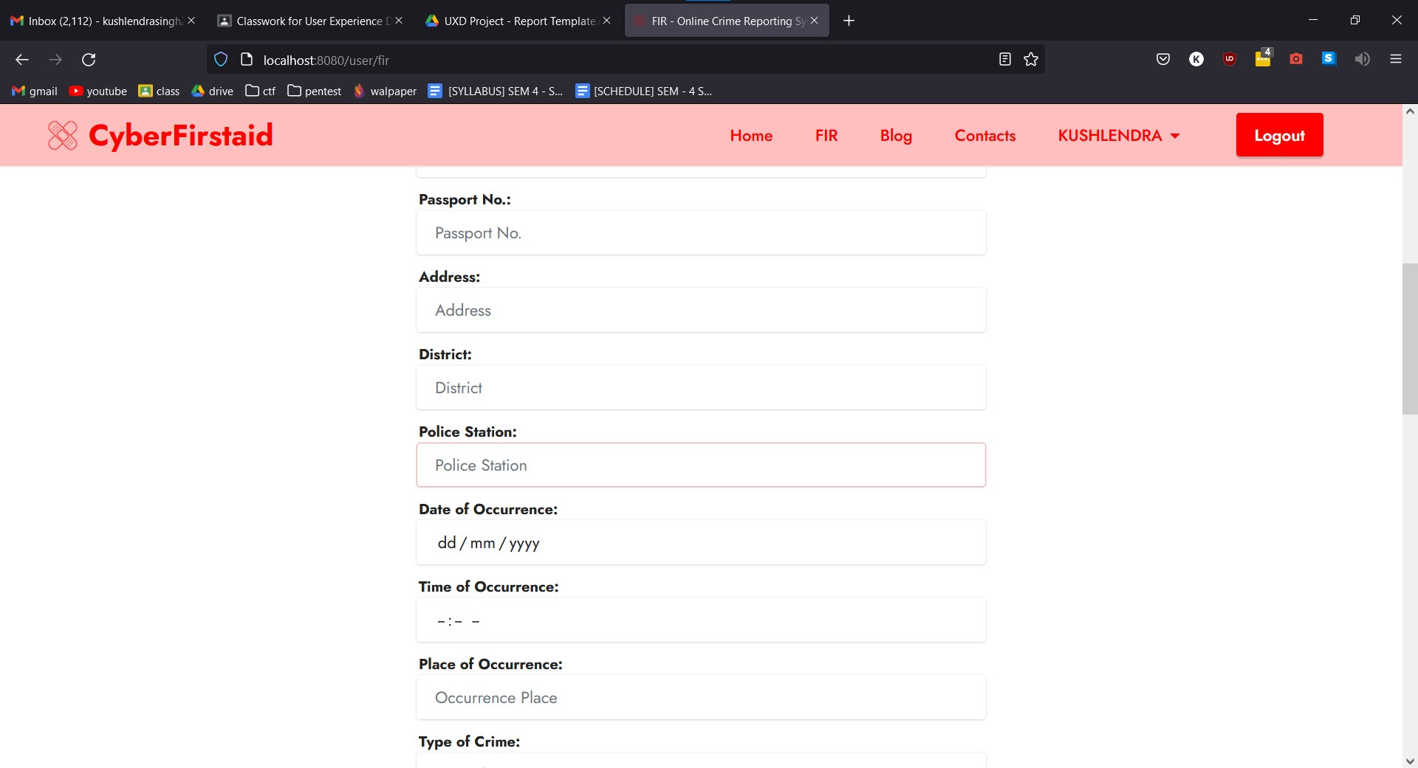

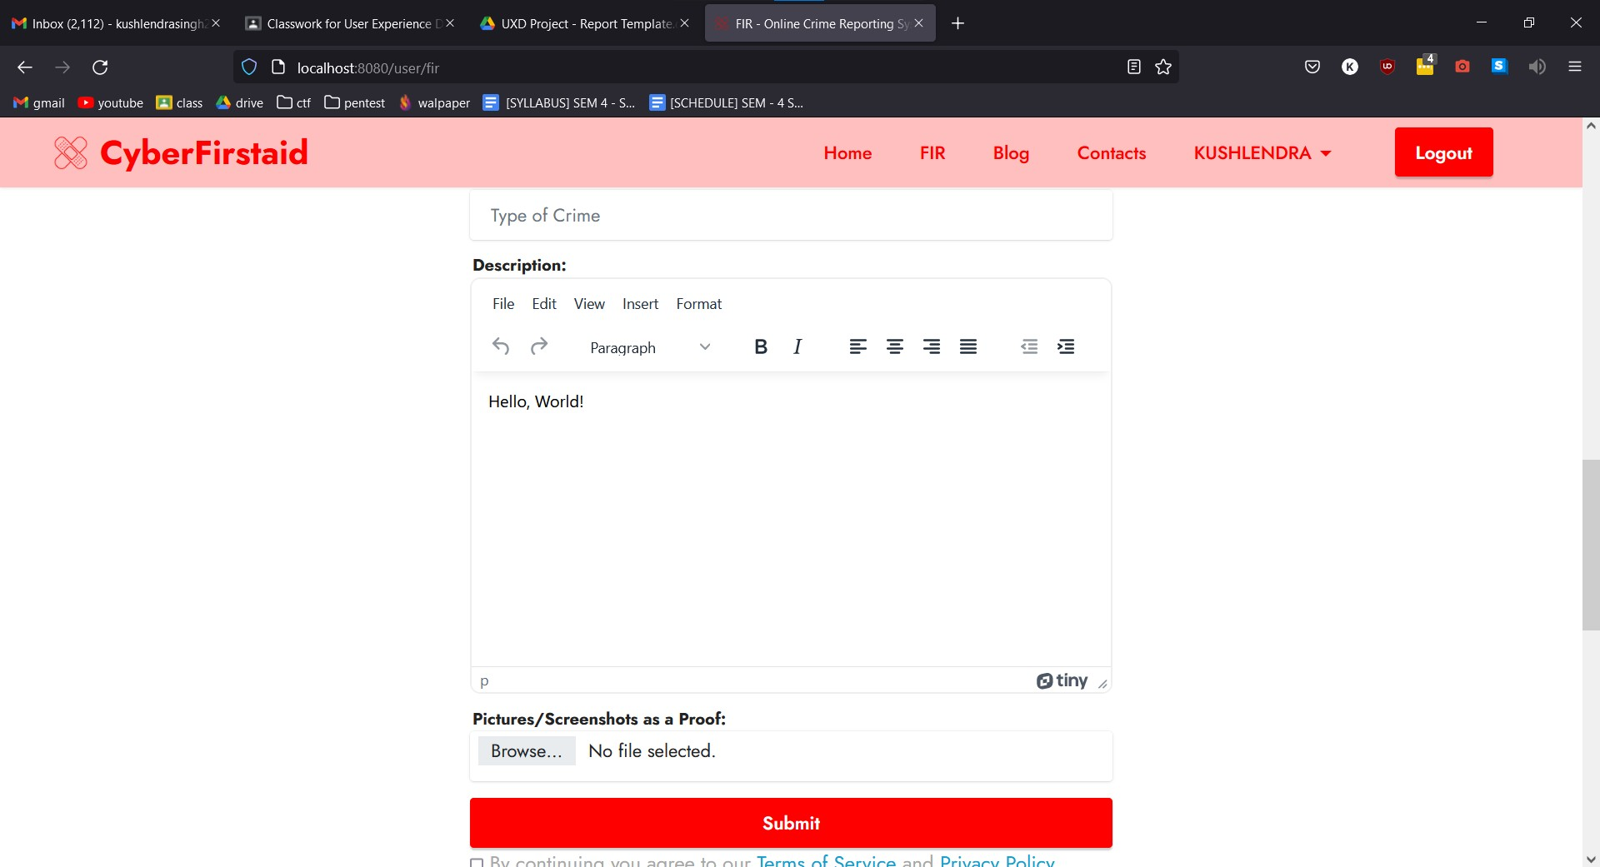

* + 1. **User Profile page**

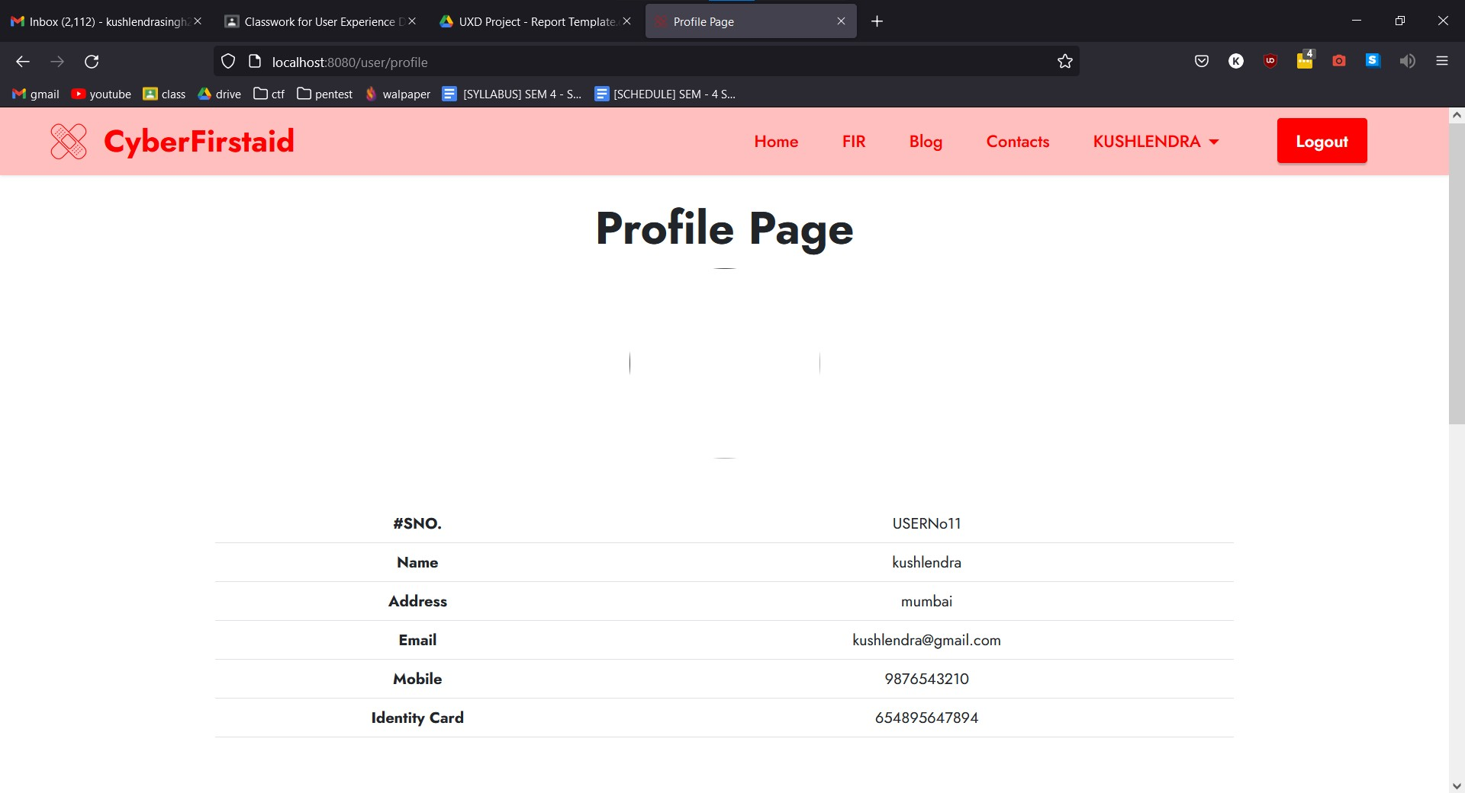

* + 1. **Officer login page**

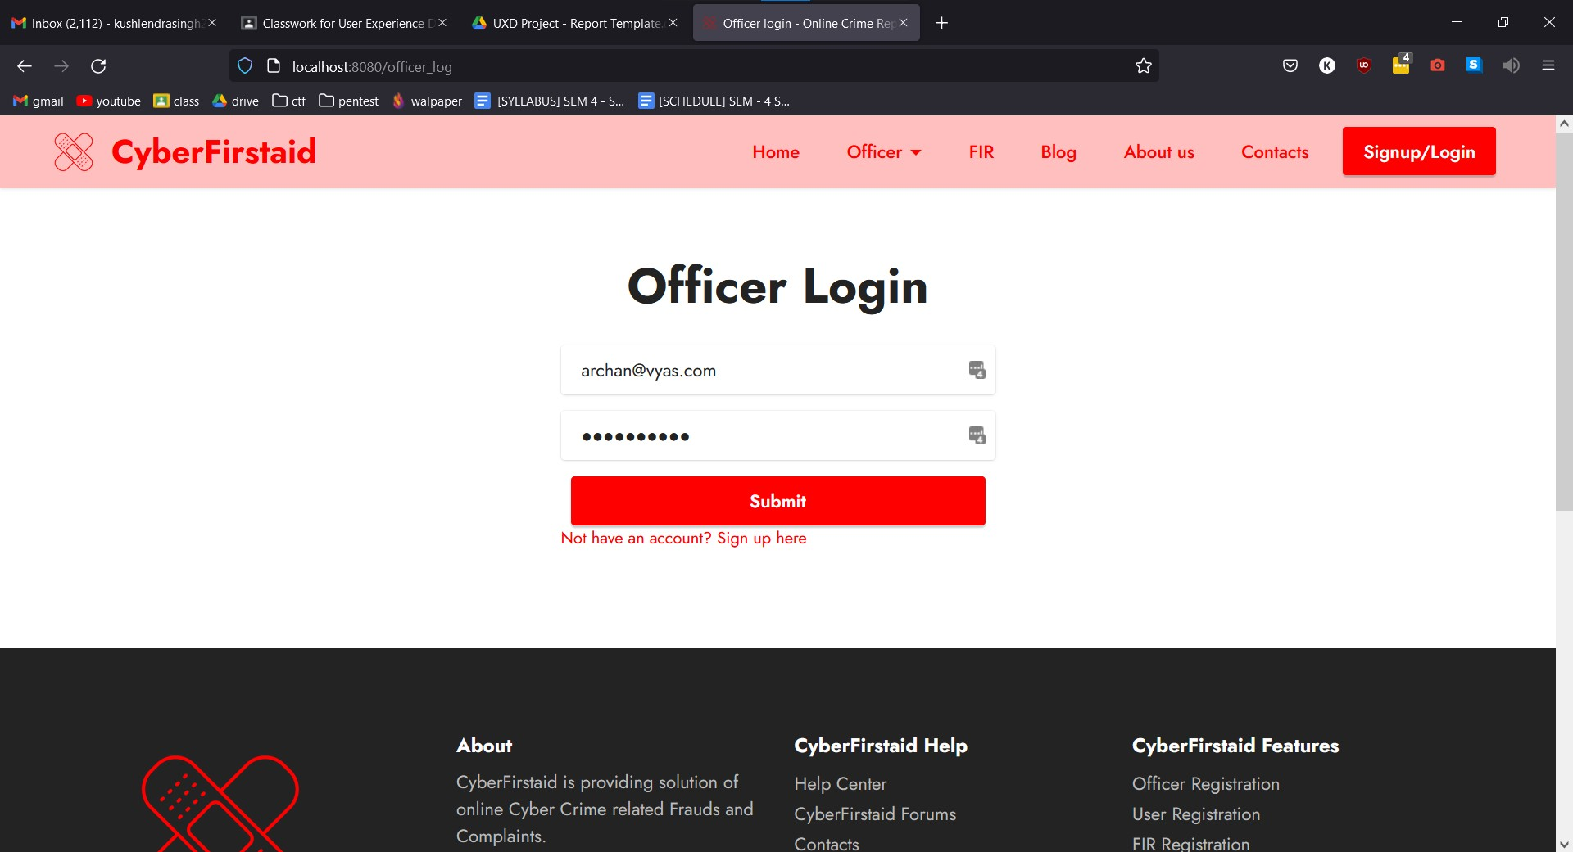

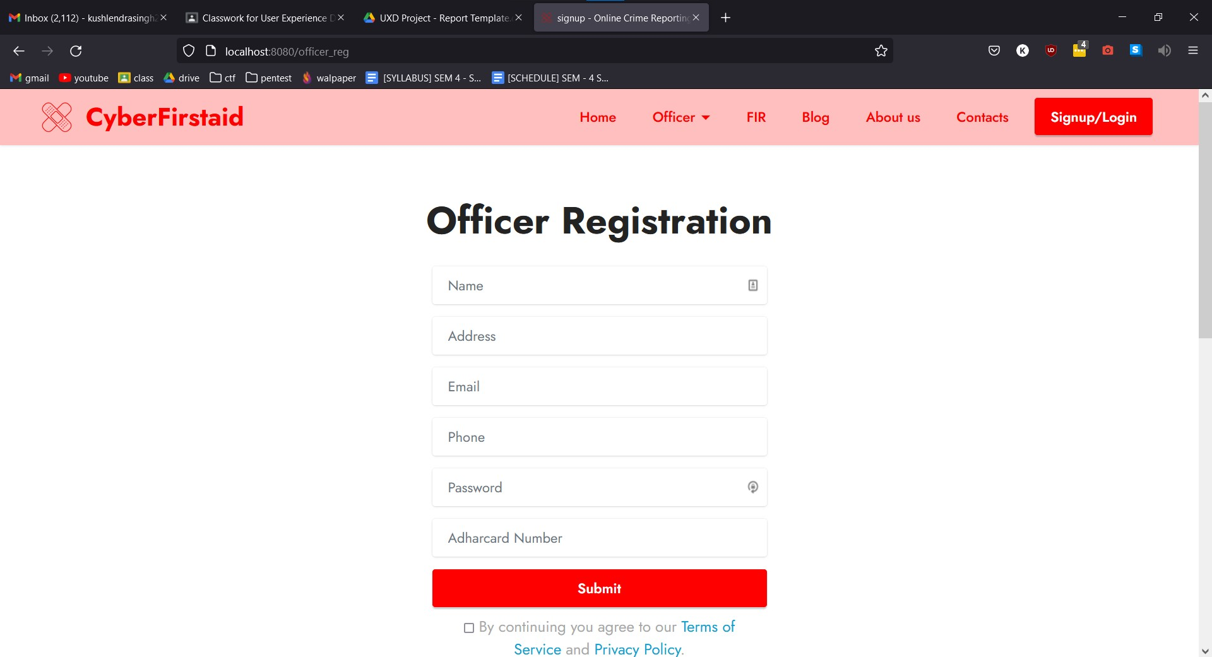

* + 1. **Officer signup page**



* + 1. **FIR Table page**

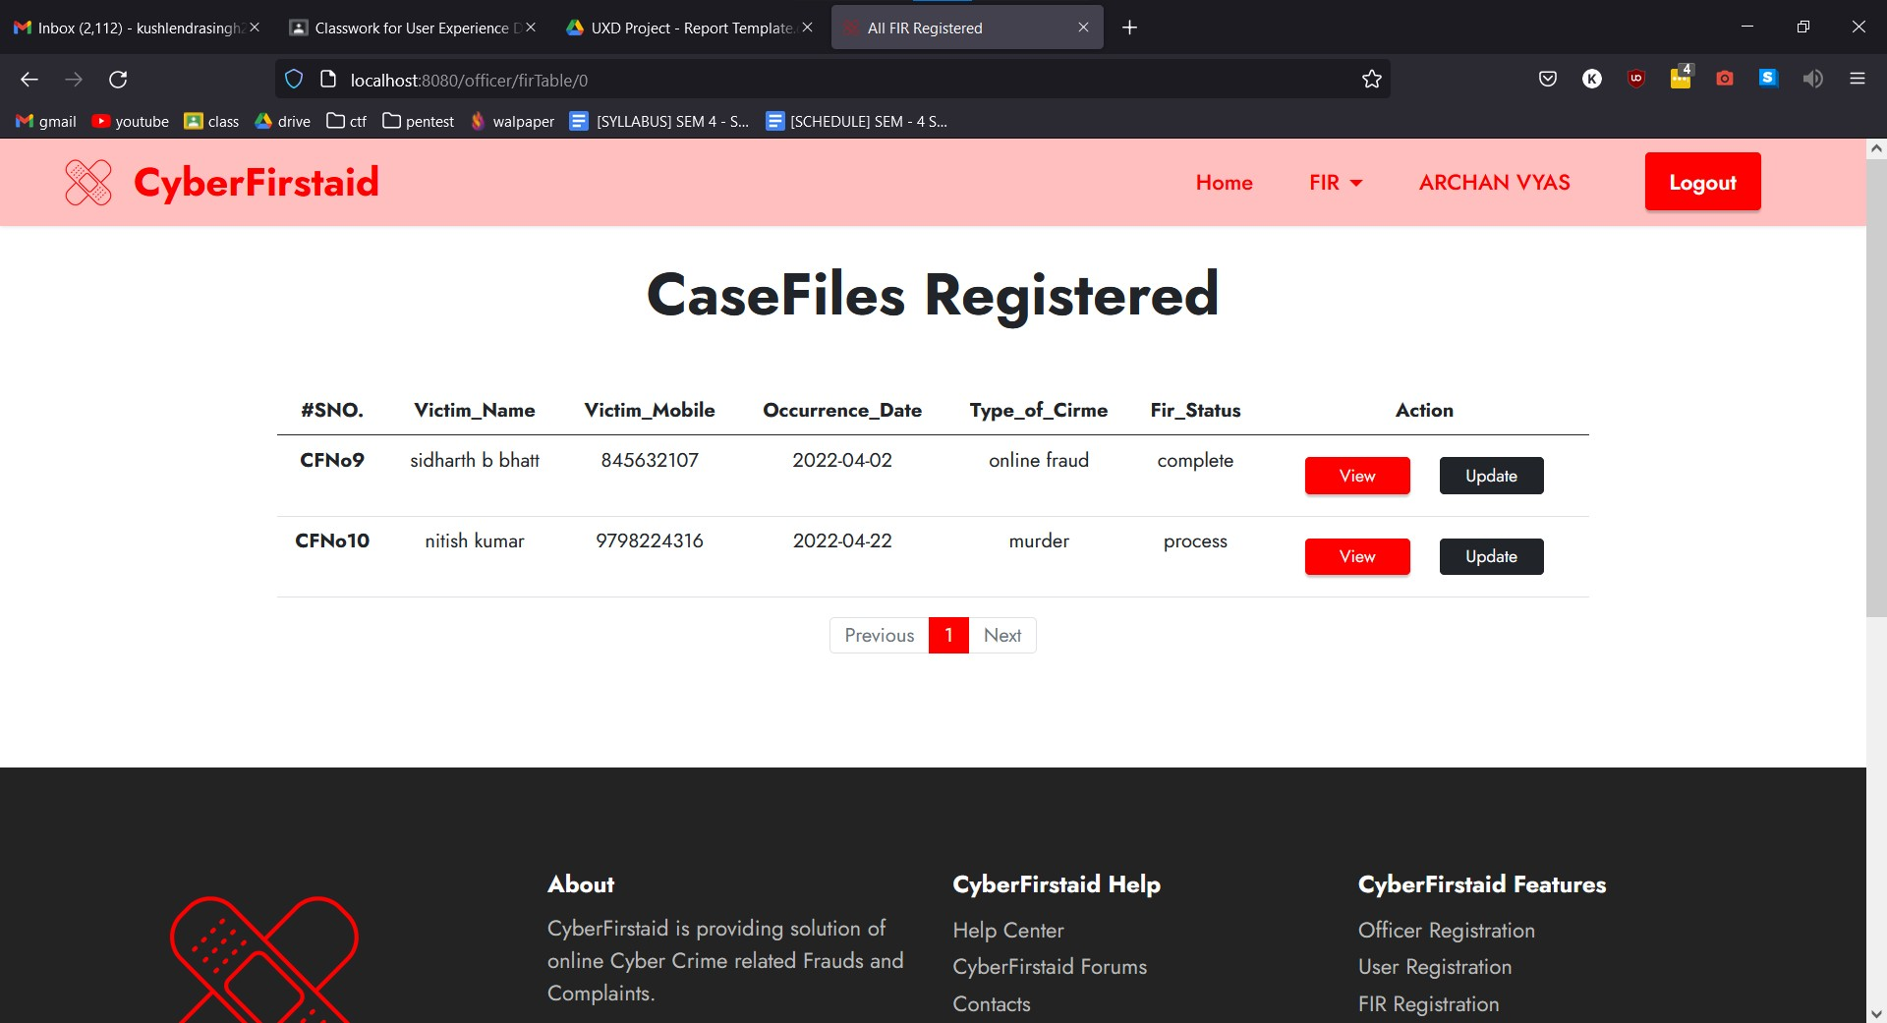

* + 1. **FIR View page**

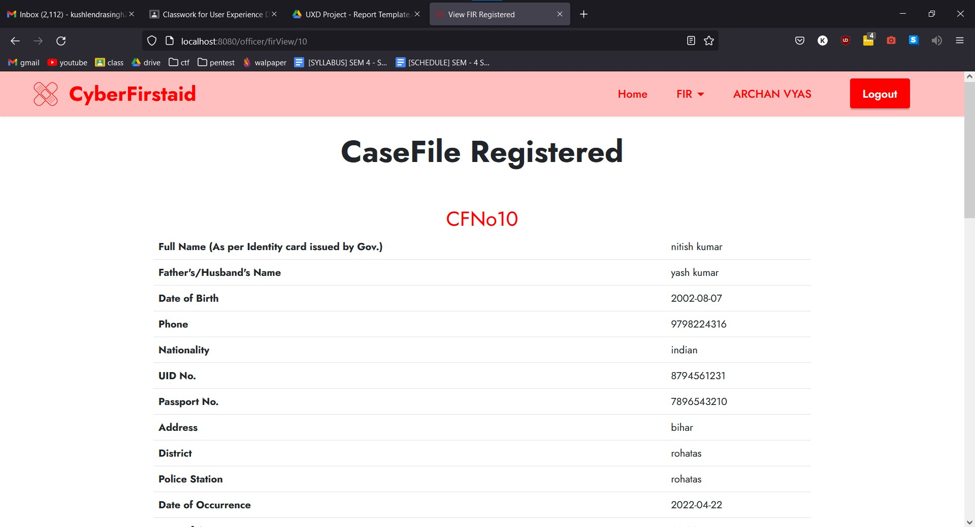

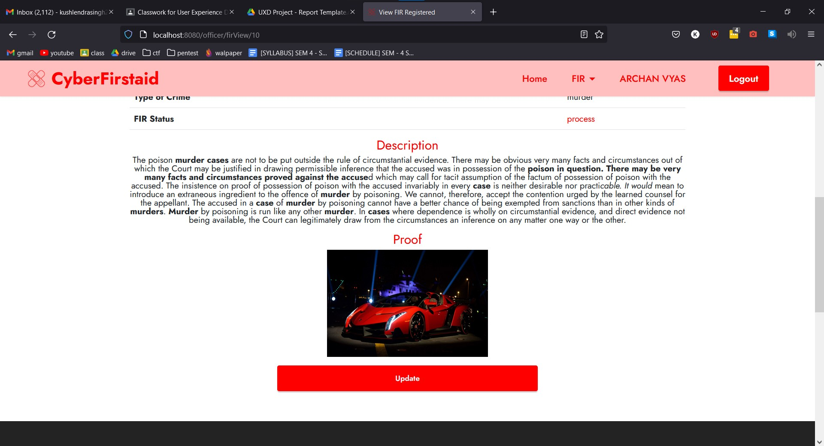

**5.1.10 FIR Update page**

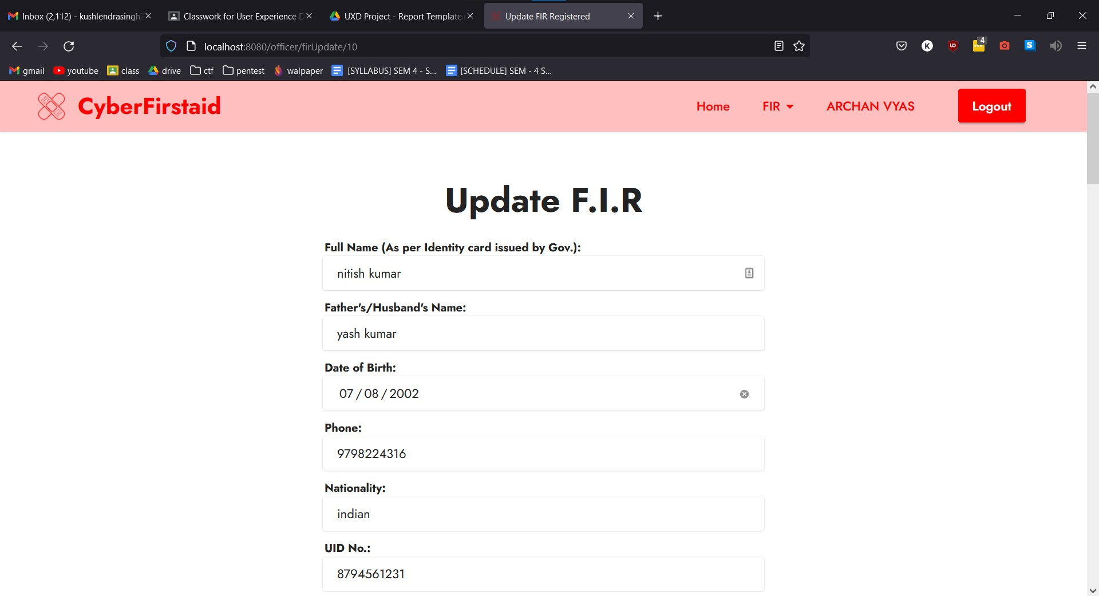

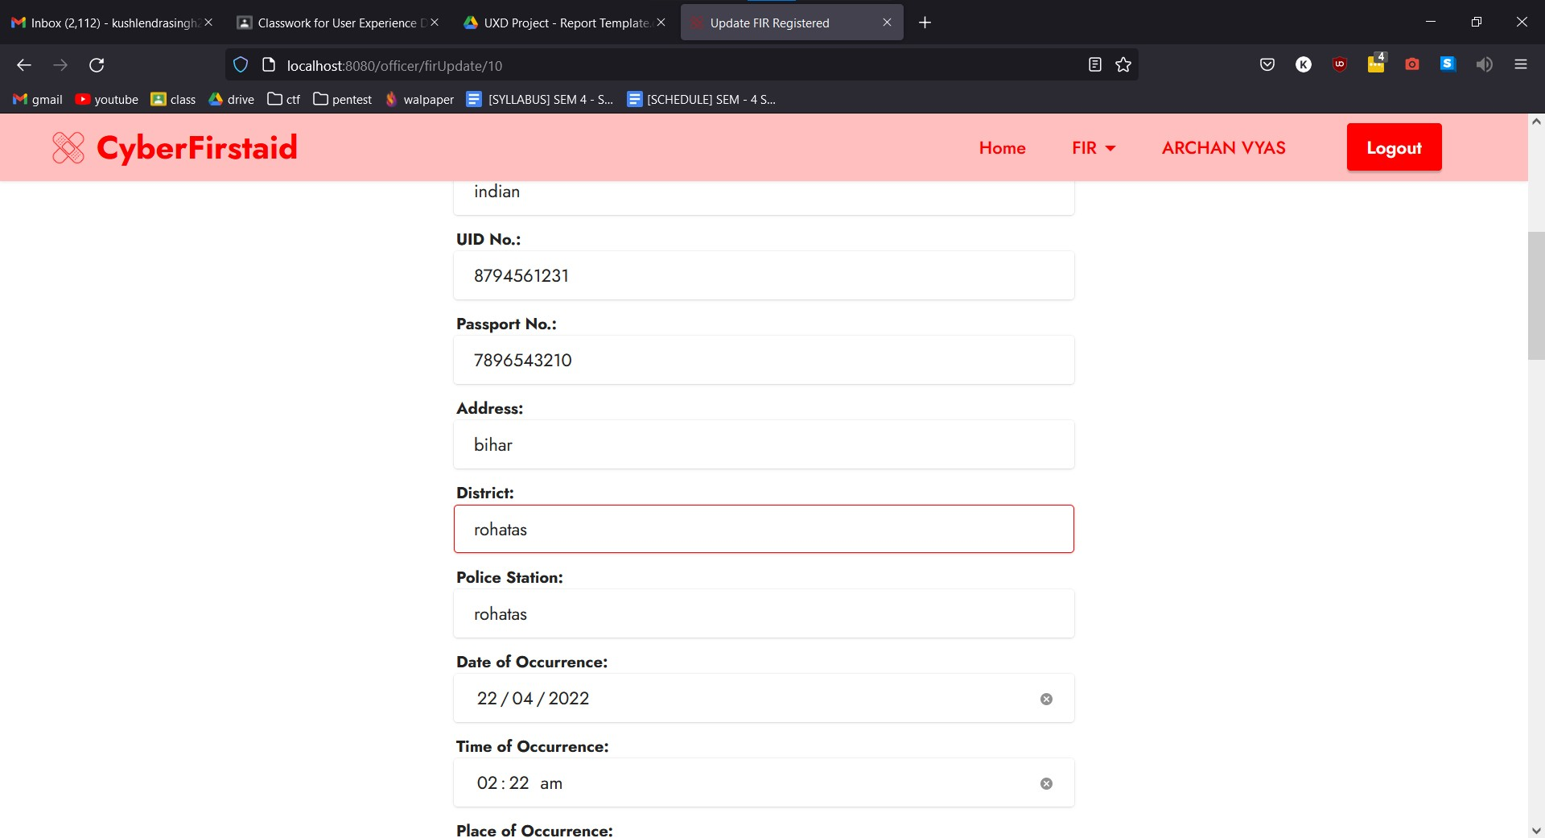

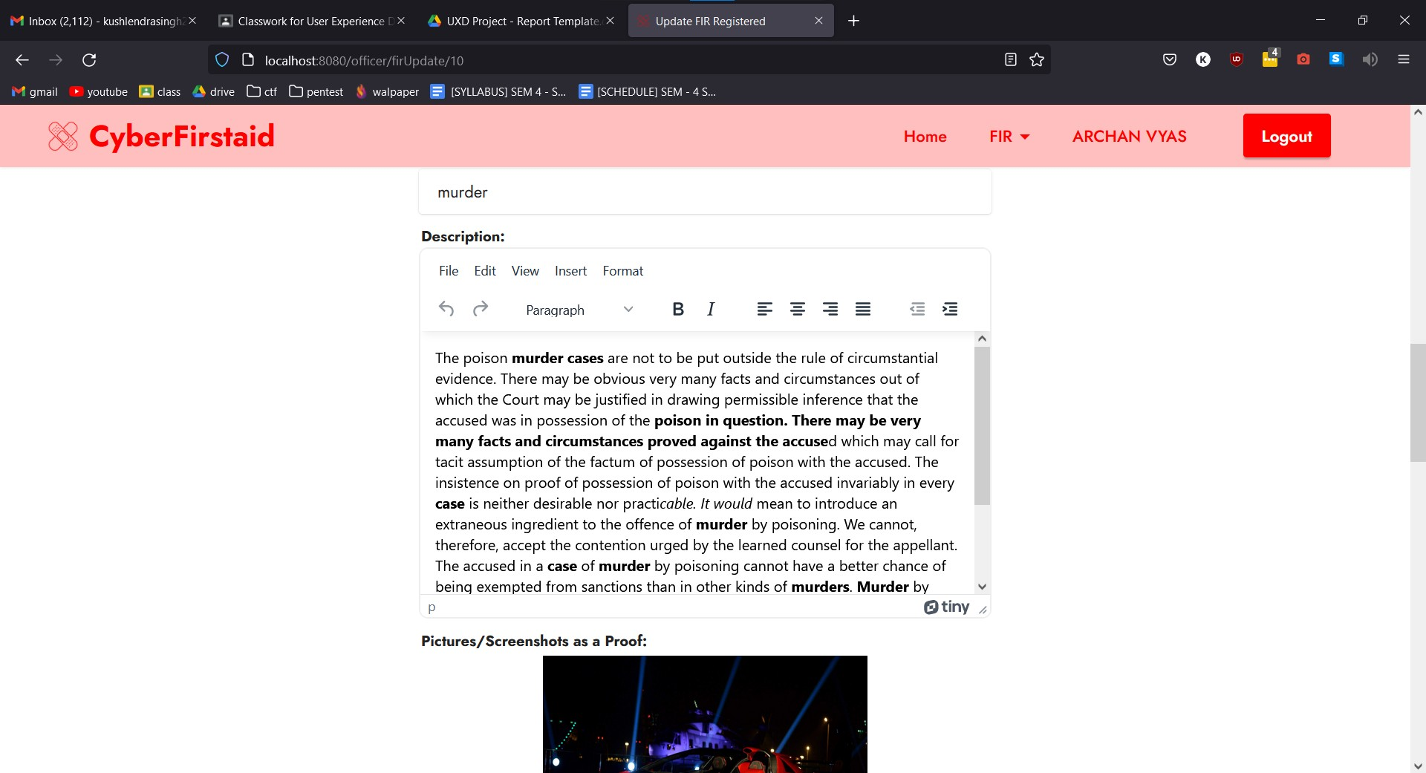

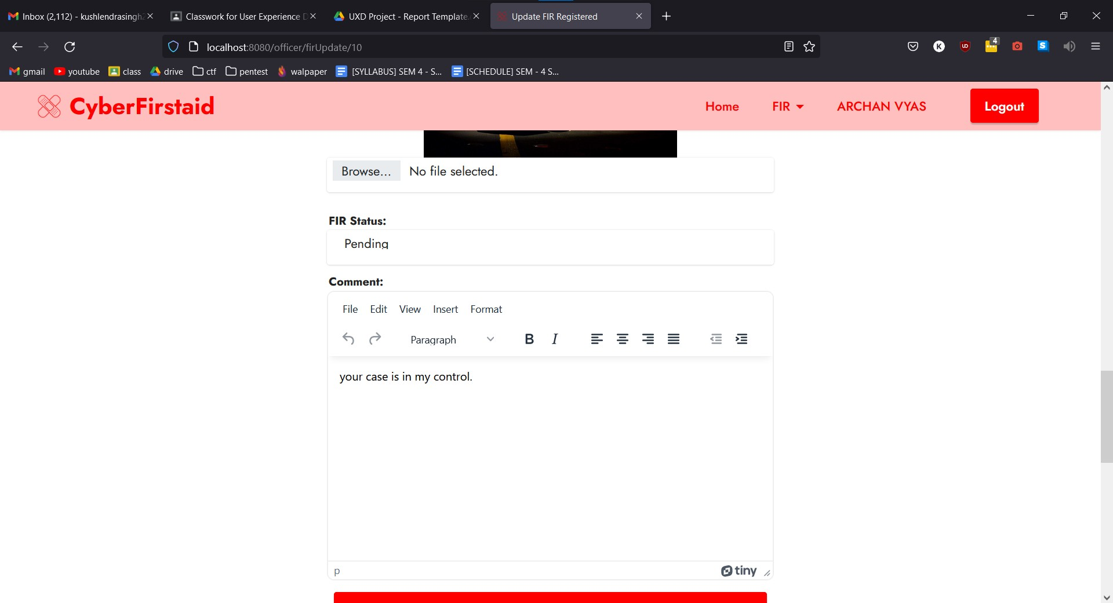

* 1. **Backend/Admin Side Screenshots**

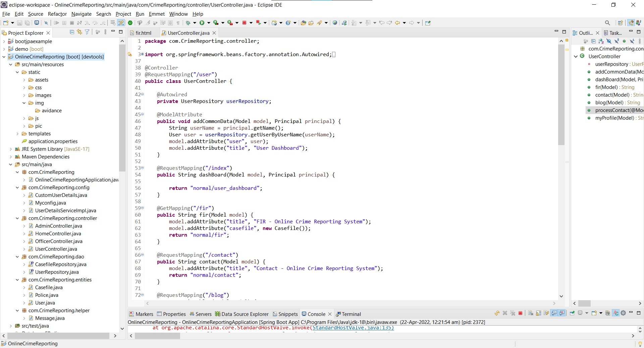

* 1. **Other Screenshots**

# Chapter 6

**Conclusion And Future Work**

In the modern world, the use of computers and Mobile phones are becoming rampant. More so, recent developments in ICT Industries have revolutionized and consequently brought about a paradigm shift in the way activities are accomplished. As a result of the crime reporting system needs to embrace these new technologies. This report has presented a simple, convenient, cost-effective, but efficient online crime reporting system with a user-friendly, sensitive and intelligible web interface. Whereby it can be accessed at any time provided there is an internet connection.

**REFERENCES**

1. [https://docs.spring.io/spring-boot/docs/current/reference/htmlsingle](https://docs.spring.io/spring-boot/docs/current/reference/htmlsingle/)/
2. [https://docs.spring.io/spring-security/reference/index.htm](https://docs.spring.io/spring-security/reference/index.html)l
3. [https://docs.spring.io/spring-framework/docs/3.2.x/spring-framework-reference/html/mvc.htm](https://docs.spring.io/spring-framework/docs/3.2.x/spring-framework-reference/html/mvc.html)l
4. <https://hibernate.org/orm/documentation/6.0/>
5. <https://www.thymeleaf.org/documentation.html>

27